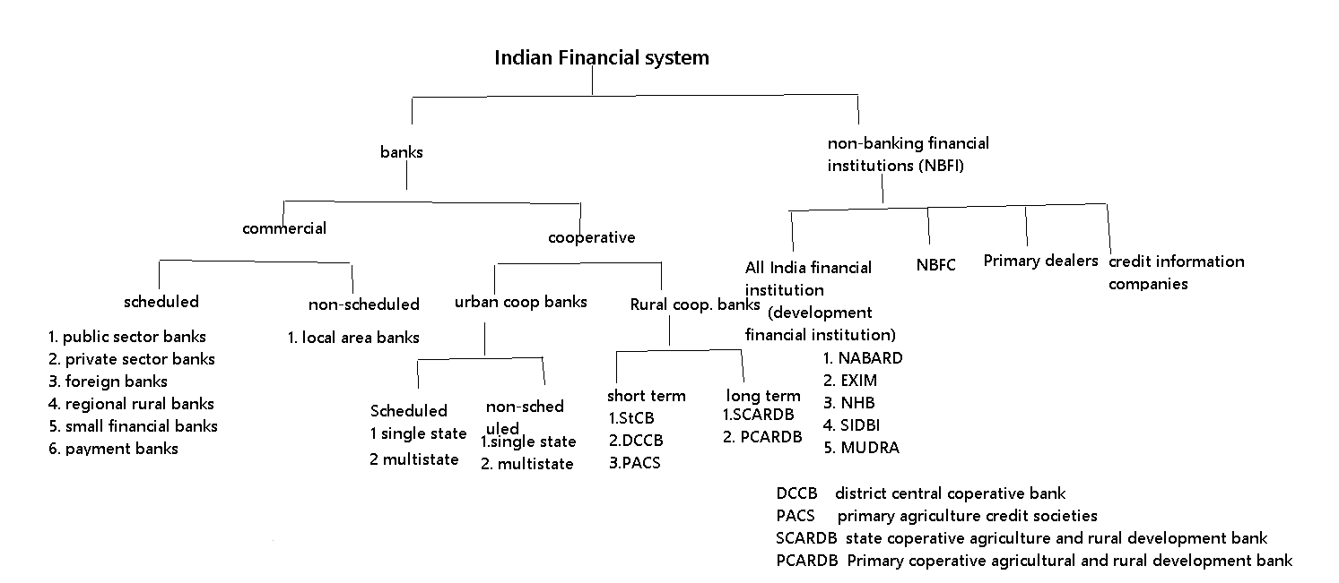

1. The financial institutions in India are broadly divided into two categories viz. Banks and Non-Banking Financial Institutions (NBFI). A bank accept demand deposits while NBFIs do not accept. The banks has authorised to issue check but NBFIs cannot issue it.

2. Banks are classified into commercial and cooperative. Commercial banks operate their business for profit purpose while the basis of operation for cooperative banks is on cooperative lines i.e. service to its members and the society. In comparison of commercial bank Cooperative banks provide higher rate of interest.

Commercial banks are of two categories viz.

1. Scheduled commercial banks
2. Non-scheduled commercial banks.

A scheduled bank is a bank that has been included in the 2nd schedule of the RBI Act 1934. A scheduled bank also had to be a corporation and the Paid-up capital for it should be at least Rs. 500 crores.

The Non-Scheduled banks have to put some reserve requirements like SLR, CRR according to the banking regulation act 1949. Scheduled Banks are required to maintain reserve requirements with RBI as per the RBI Act 1934.

3. Co-operative Banks:

These are of two types-

1. Urban Co-operative banks (UCB)
2. Rural Co-operative banks.

The Urban Co-operative banks (UCB) are also known as Primary Co-operative Banks. They help the communities, localities, work place groups and setup mostly in urban and semi urban areas. There main customers are mainly small borrowers and businesses.

These UCBs are also classified into Scheduled and Non-scheduled categories, which are then further classified into single state and multi state.

Important point:

The Malegam Committee proposed a new organisational structure consisting of a Board of Management (BoM) in addition to the Board of Directors (BoD) to strengthen the governance and functioning of Urban-Cooperative Banks (UCBs) (2011).

4. Public Sector Banks:

Banks controlled by the federal or state governments, with a combined ownership of more than 51 percent. SBI and its affiliates, Punjab National Bank, Bank of India, and others are examples. Those Nationalized Banks (private banks taken over by government) which were nationalized in 1969 and 1980’s are also public sector banks as government owns more than 51% in these banks.

5. Private Sector Banks:

These are those Indian Banks that are owned by private individuals for example ICICI bank, HDFC bank, Axis Bank etc.

6. Foreign Banks:

Those Banks that are established and provided services of banking in India but owned by foreign entities are called foreign banks. for example Citi Bank, HSBC Banks, Standard chartered banks etc.

7. Regional Rural Banks (RRBs):

The Regional Rural Banks Act of 1976 established RRBs in 1975 with the goal of developing the rural economy by providing credit and other facilities, particularly to small and marginal farmers, agricultural labourers, artisans, and small entrepreneurs, for the purpose of developing agriculture, trade, commerce, industry, and other productive activities in rural areas. The national government, the concerned state government, and the sponsor bank each own 50:15:35 of RRBs (each RRB is sponsored by a particular bank). RRBs are required to distribute 75% of their funding to priority industries. NABARD also supervised RRBs.

8. Local Area Banks (LAB):

They were established in 1996 as part of a Government of India scheme. The government intended to establish new private local banks with control over two or three adjacent areas. The goal of establishing local area banks was to allow local institutions to mobilise rural savings and make them available for investments in local areas. There are just four Non-Scheduled Local Area Banks in India, one of which is Coastal Local Area Bank in Vijayawada, Andhra Pradesh.

The RBI regulates and supervises three main areas of the Non-Banking Financial Institutions (NBFIs) sector in India: All India Financial Institutions (AIFIs), Non-Banking Financial Companies (NBFCs), and Primary Dealers (PDs). Credit Information Companies (CIC) are a type of non-banking financial organisation regulated by the Reserve Bank of India.

9. AIFIs are institutional mechanisms tasked with delivering long-term finance to specific sectors. The RBI currently regulates and supervises four AIFIs, also known as Development Financial Institutions (DFIs).

10. NABARD:

NABARD was established in 1982 under the provisions of National Bank for Agriculture and Rural Development Act 1981. NABARD give credit to promote agriculture, small scale industries, cottage and village industries, handicrafts and other rural crafts and other allied economic activities in rural areas. NABARD extends assistance to the government, RBI and other organizations in matters relating to rural development. It offers training and research facilities for banks, cooperatives and organizations in matters relating to rural development

11. Small Industries Development Bank of India (SIDBI):

SIDBI was established in 1990 under the provisions of Small Industries Development of India Act 1989SIDBI serves as the primary financial institution for promoting, funding, and developing the Micro, Small, and Medium Enterprise (MSME) sector, as well as for coordinating the functions of other organisations involved in similar activities. SIDBI primarily provides banking institutions with indirect financial support (in the form of refinancing) in order for them to lend to MSMEs.

12. MUDRA Bank:

MUDRA (Micro Units Growth and Refinance Agency Ltd.) is a government-owned financial agency dedicated to the development and refinancing of micro-enterprises. MUDRA Ltd, a non-banking finance company, has been set up as a subsidiary of SIDBI pending the passing of an act creating MUDRA Bank. MUDRA's goal is to provide funding to non-corporate (informal sector) small businesses in rural and urban areas with financing needs of up to Rs 10 lakhs, such as small manufacturing units, shopkeepers, etc. MUDRA would be in charge of refinancing all Last Mile Financiers, including Micro Financial Institutions, Non-Banking Finance Companies, Societies, Trusts, Companies, Co-operative Societies, Small Banks, Scheduled Commercial Banks, and Regional Rural Banks, who lend to micro/small business entities engaged in manufacturing, trading, and services.

13. Non-Banking Financial Companies (NBFCs):

The NBFC is a company governed by the Companies Act, 1956/2013, that deals with loans and advances, the acquisition of shares/bonds/debentures issued by the government or a local authority, or other marketable securities of a similar nature, leasing, hire-purchase, insurance, and chit business, but not with agriculture, industrial activity, or the purchase or sale of any goods. Private sector institutions make up the majority of NBFCs.

14. Primary dealers (PDs):

Primary dealers are RBI-registered companies with the authority to buy and sell government securities. In the primary market, PDs purchase government securities directly from the government (RBI issues these assets on behalf of the government), with the intention of reselling them to other buyers in the secondary market. As a result, they play an important role in the primary and secondary government securities markets.

15. Credit Information Companies (CIC):

A CIC is a non-profit organisation that accepts banks, NBFCs, and financial institutions as members and collects data and identity information for individual customers and enterprises. CICs tell banks whether or not a potential borrower is creditworthy based on his payment history. The ability of lenders to assess risk and of consumers to receive credit at competitive rates is determined by the quality of information available. The RBI regulates and licences credit information companies (CICs) under the Credit Information Companies (Regulation) Act 2005. TransUnion Credit Information Bureau of India Limited (CIBIL), Equifax, Experian, and High Mark Credit Information Services are the four CICs currently operating in India.

16. Payment Banks:

In August 2015, the Reserve Bank of India (RBI) approved 11 applications for Payment Bank licences. The Reserve Bank of India has capped the amount of deposits that payment banks can receive from individuals at Rs. 1 lakh. Only those companies that are truly engaged in targeting the poor will be able to apply for payment bank licences as a result of this restriction. As a result, migrant workers, self-employed individuals, low-income households, and others will be the primary beneficiaries of payment banks' low-cost savings accounts and remittance services, allowing those who currently transact only in cash to make their first foray into the formal banking system (payment banks will not be permitted to lend or issue credit cards). Only demand deposits will be accepted by payment banks.

17. Small Finance Banks:

In September 2015, RBI granted license to 10 applicants for Small Finance Banks which is a step in the direction of furthering the financial inclusion.

The small finance banks shall primarily undertake basic banking activities of acceptance of deposits and lending to unserved and underserved sections including small business units, small and marginal farmers, micro and small industries and unorganized sector entities.